[**Introduction to NP-Completeness**](https://www.goeduhub.com/10095/introduction-to-np-completeness)

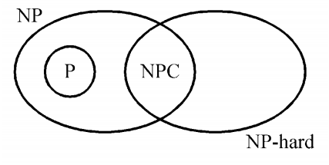

**P:** is the set of decision problems that are solvable in polynomial time.

**NP:** is the set of decision problems that can be verified in polynomial time.

**NP-Hard:** L is NP-hard if for all L' ϵ NP, L' ≤p L. Thus if we can solve L in polynomial time, we can solve all NP problems in polynomial time.

**NP-Complete:** L is NP-complete if

1. L ϵ NP and
2. L is NP-hard

***NP-Complete Problems***

Following are some NP-Complete problems, for which no polynomial time algorithm is known.

* Determining whether a graph has a Hamiltonian cycle
* Determining whether a Boolean formula is satisfiable, etc.

***NP-Hard Problems***

The following problems are NP-Hard

* The circuit- satisfiability problem
* Set Cover
* Vertex Cover
* Travelling Salesman Problem